DATA WAREHOUSING AND SQL  
  
  
ALY6030, SPRING 2020  
MODULE 2 PROJECT ASSIGNMENT

WEEK 4: HOSPITAL NURSING INTERVENTION PILOT PROGRAM

SUBMITTED BY: SHIVANI ADSAR

NUID: 001399374

SUBMITTED TO: PROF. DAYA RUDRAMOORTHI

DATE: 06/14/2020

**Introduction**

The assignment aims at providing practical experience in developing sql queries for maintaining a hospital management system. As per the data provided, the leadership wants to hire more nurses, in the ACME’s hospital network so that the Intensive Care Units (ICU’s) and Surgical Intensive Care Units (SICU’s) would could take care of critical patients. Since, the intervention would be selecting one or two hospitals as the pilot sites, we would be working on providing the top10 hospitals based upon the bed count. Moreover, we would be using the concept of facts and dimension tables for connecting the two dimension tables and one fact table.

**Analysis**

**Step 1: Identify the dimensions from each dimension table**

* A dimension table is primarily used in Star Schema of a data warehouse. The data warehouses manage their data using fact and dimension tables. The dimension tables are used for describing the dimensions like, keys, values and attributes.
* Moreover, a fact table contains measures and is the central table that is stored in a star schema. In addition, the fact table stores quantitative information for analysis.
* The table, ‘bed_type’, contains dimensional data with columns like, bed_id, bed_code and bed_desc. Also, the table does not contain any numeric values, hence this table can be considered as a dimension table.
* In addition, the table, ‘business’, contains attributes like, ttl_license_beds, ttl_census_beds and ttl_staffed_beds, as they provide information about the total number of license, census and staffed beds which can be considered as Facts.

**Step 2: Identify the Facts variables from the single Fact Table**

* The ‘bed_fact’ table consists of attributes like, license_beds, census_beds and staffed_beds that conveys meaningful information about the number of beds in each category. Hence, these values can be considered as facts.
* However, some columns like, ims_org_id and bed_id can be considered as dimensions as they show descriptive attributes.

**Step 3: Sketch out a Star Schema using MySQL Workbench**

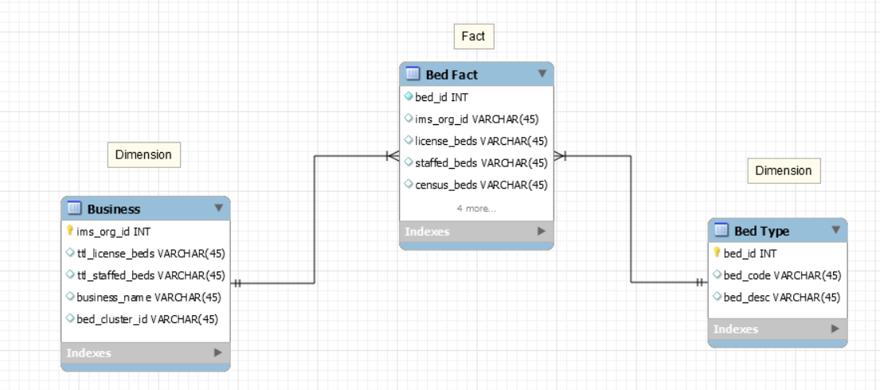

Fig.1: Star Schema

**Step 4a: Analysis for Leadership**

Since we have three CSV files that are required to be uploaded in the SQL Workbench, we have initially imported the database table named, ‘hospital’. Further, by right clicking on the database name, we have selected the ‘Table Data Import Wizard’ for importing the three csv files.

1. License beds: List of Top 10 Hospitals ordered descending by the total ICU or SICU license beds.

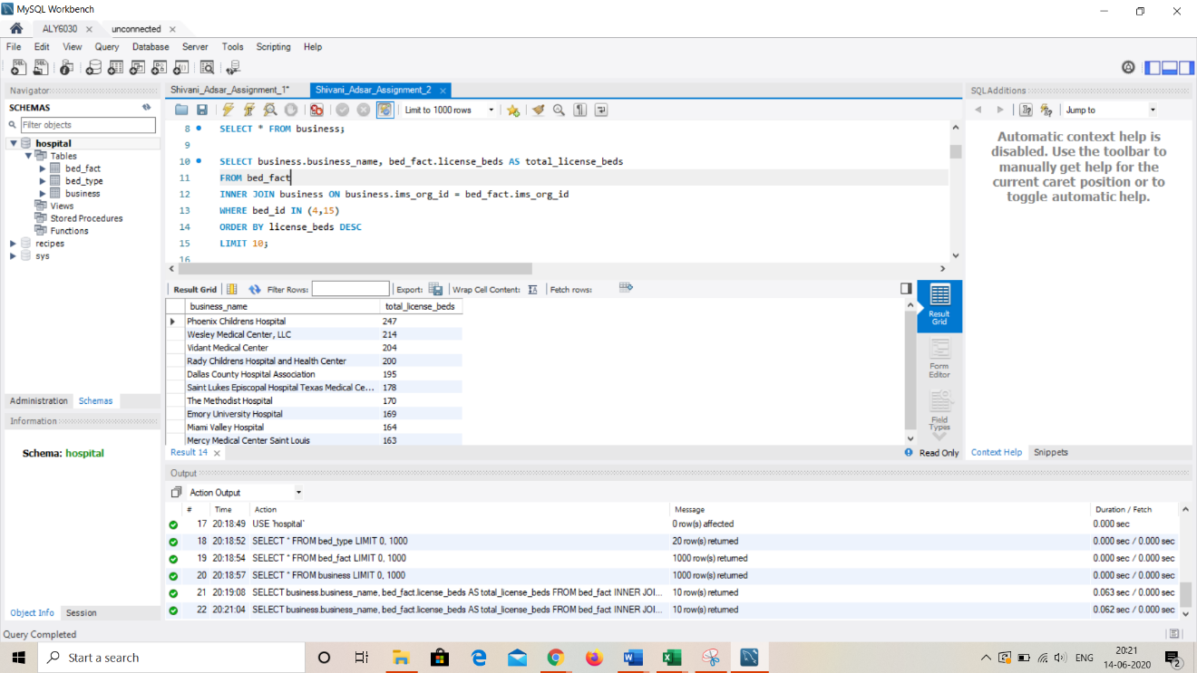

Fig.2: List of top 10 license beds

1. Census beds. List of Top 10 Hospitals ordered by total icu or sicu census beds.

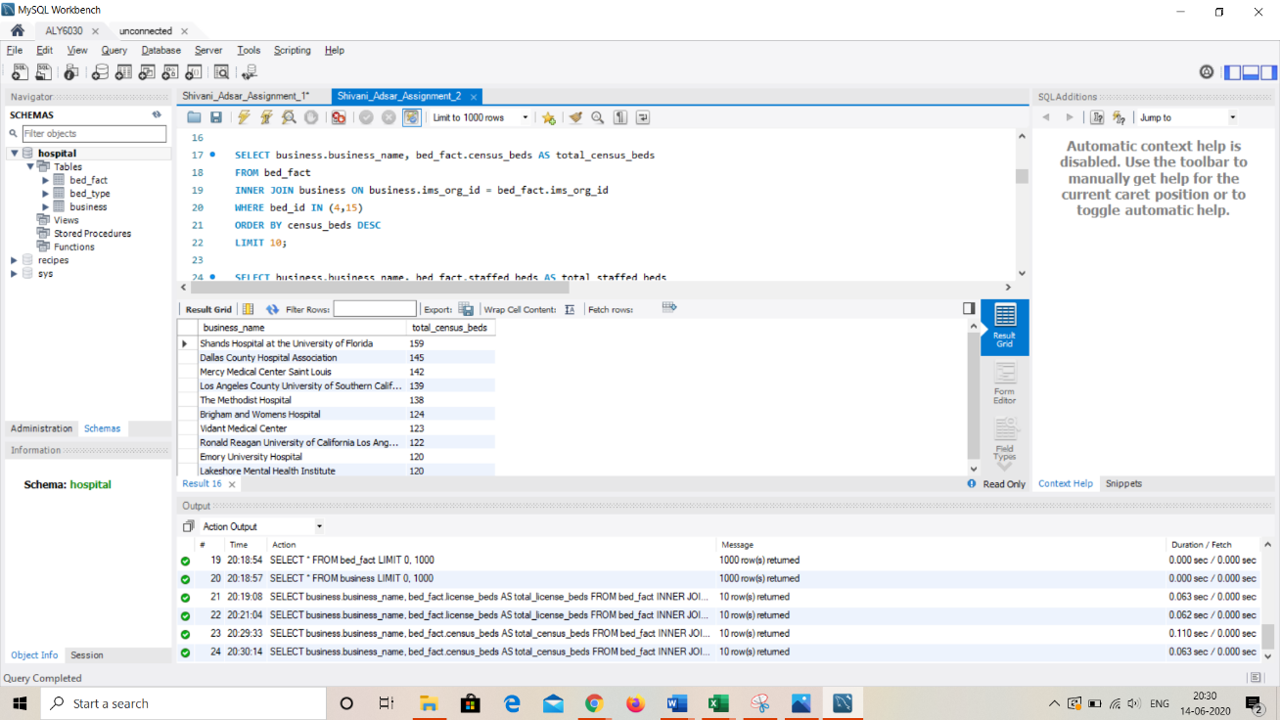

Fig.3: List of top 10 Census beds

1. List of Top 10 Hospitals ordered by the total icu or sicu staffed beds

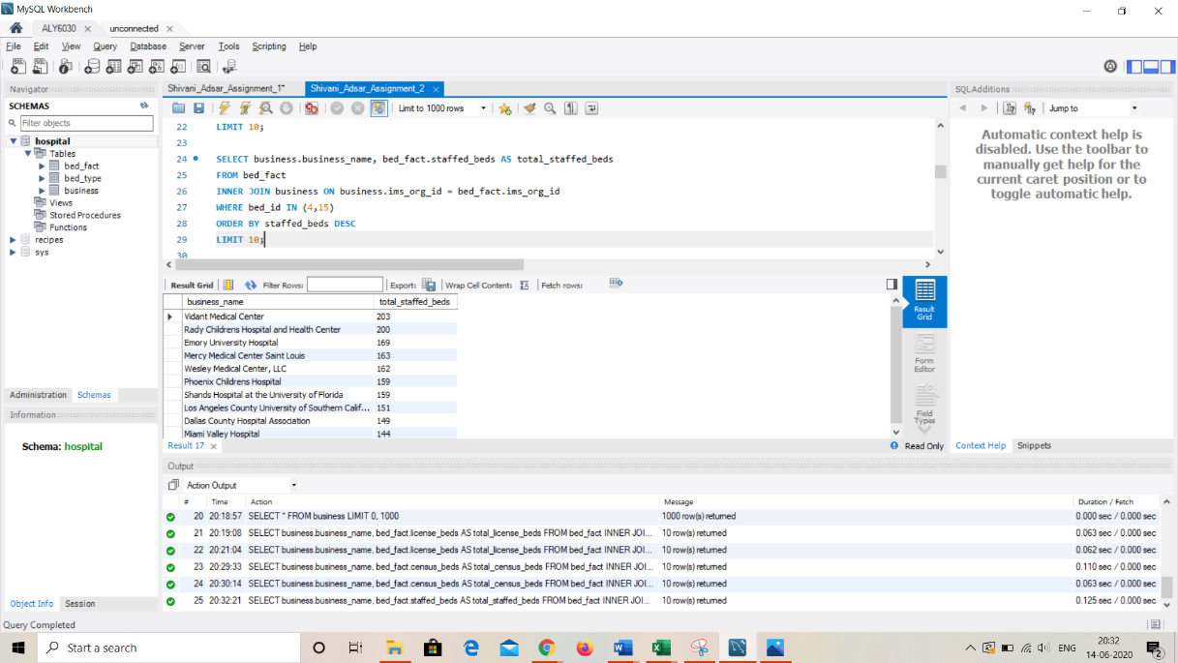

Fig.4: List of top 10 Staffed beds

**4b: Interpretation of findings**

We can interpret that, the Vidant Medical Center has 203 staffed beds and 204 license beds. In addition, Phoenix Children’s Hospital has 247 license beds and 159 staffed beds. Moreover, the Shand’s Hospital at the University of Florida, has 159 census and staffed beds. Therefore, it can be interpreted that, these hospitals have higher number of employed nurses and critical patients.

**5a: Drill down the investigation**

1. Top 10 hospitals that have both kinds of licensed ICU and SICU beds

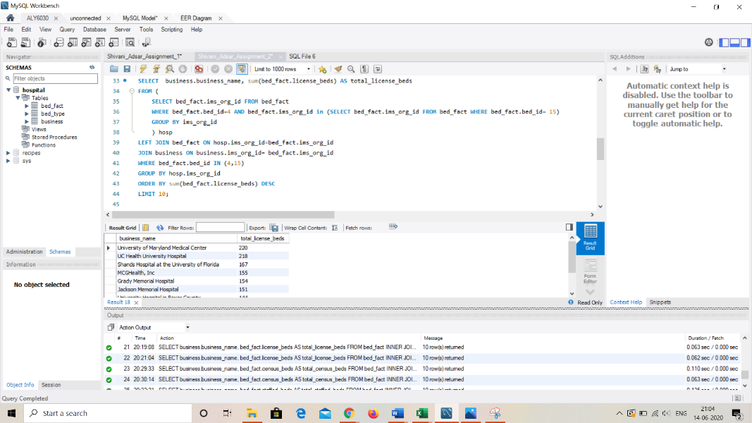

Fig.5: List of top 10 hospitals with licensed ICU and SICU beds

1. Top 10 hospitals that have both kinds of census ICU and SICU beds.

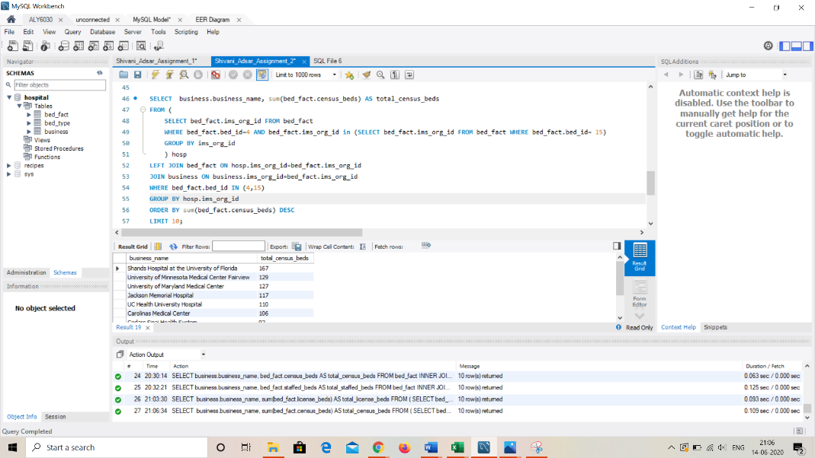

Fig.6: List of top 10 hospitals with Census ICU and SICU beds

3) Top 10 hospitals that have both kinds of staffed ICU and SICU beds.

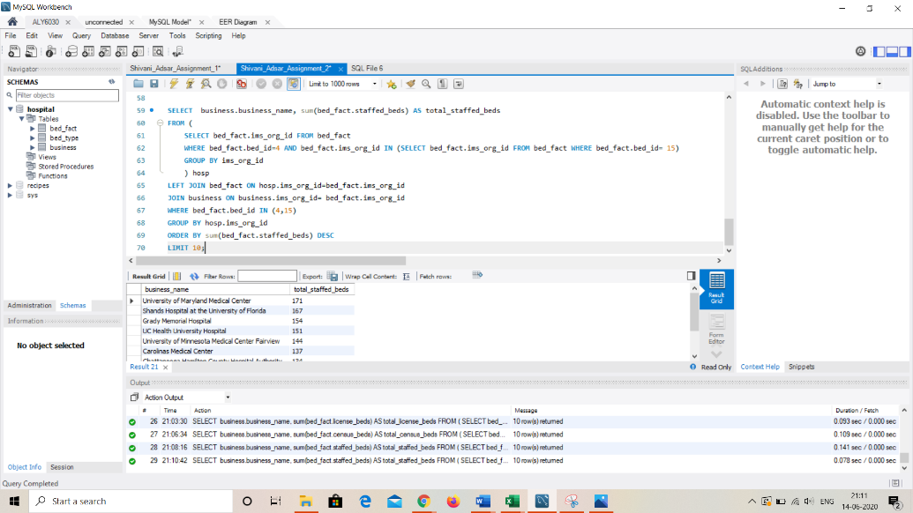

Fig.7: List of top 10 hospitals with Staffed ICU and SICU beds

**5b: Final recommendation**

We can observe that, the University of Maryland Medical Center, has 220 license beds, 129 census beds and 171 staffed beds. Therefore, this hospital seems to have facilities to accommodate more number of patients and can be considered as one of the preferences amongst patients in that area. It can be noted that the hospital can have 220 license beds, which they are allowed by the state government. Also, the staffed beds seem to be 171, which means more availability of nurses to take care of the patients.

After analyzing, I would recommend, University of Maryland Medical Center and Shand’s Hospital at the University of Florida for their pilot site.

**Conclusion**

We have learnt the importance of facts and dimension tables while retrieving the data from databases. Moreover, we have learnt the usage of nested SELECT statements in getting the desired results. This has helped in recommending the best pilot sites.

**References**

[1] Comeau A. (2015). MySQL Explained: Your Step-by-Step Guide

[2] Difference Between Fact Table and Dimension Table. (n.d.). Retrieved June 15, 2020, from https://www.guru99.com/fact-table-vs-dimension-table.html